Project SG2212/SG3114

Development/assessment of a 2D Navier-Stokes solver

Yanjun Zhang [yanjunzh@kth.se](mailto:yanjunzh@kth.se) 23/03/2023

# Task 1 Lid-driven cavity

## Q1 Kron operator

kron(A,B) returns the Kronecker tensor product of matrices A and B. If A is an m-by-n matrix and B is a p-by-q matrix, then kron(A,B) is an m*p-by-n*q matrix formed by taking all possible products between the elements of A and the matrix B.

For this project, it is a two-dimensional case, pressure P in x and y directions are calculated in same column. As seen in equation (0.2), is the relationship between laplace operator *Lp*, pressure *P* and right hand side *rhs*. The P is calucated by Lp\rhs, and rhs(reshape of DxU+DyV) is also a column, so Laplace operator Lp should be a matrix. This matrix include how to calculate second derivative of Ux and Vy.



## Q2 Maximum time step



According to experiment, when dt=0.007, the scheme is unstable, while dt=0.006944 is still stable. As shown in equation (0.2), the first term is diffusion term, which shows the delta t is 0.006944, the same as the ‘experiment’ maximum delta t. So, we could say, for both CFL and diffusion term, the combination case, the viscous limit is necessary and sufficient.

For the case A-C, the main difference is Re number. For the low Re, viscous is stricter. While for the high Re, the convection is more strict. These could be supported by the equation (0.2).

PhD question:

Scalar equation is less stable than the momentum equations. The reason is Pe=Re*Pr. If the Pr=1, the two equations have same stability limit. According to Pr=0.71, the maximum time step for scalar equation should 0.006944*0.71=0.00493, which is evaluated by MATLAB that it is correct. When the dt=0.00493, the momentum equation is stable while the scalar equation, or said temperature is blow up.

## Q3 Boundary conditions



## Q4 Re and stable time

As shown in figure 1, the larger the Re, the more time needed to steady. Case A and case B finally get steady while for case C, the Re=5000, after 50s, the system is still unstable. Maybe for case C, it needs more than 200s to get steady. The logic for these phenomena is large Re cause chaotic, like turbulent, which is unsteady.

Figure Case A, Re=25 , Case B, Re=250, Case C, Re=5000



## Q5 OpenFoam and Matlab

As shown in figure 2, is the comparison of the velocity profile along the center plane obtained with OpenFOAM and Matlab. It could see that Matlab result is very close to OpenFoam, while still there is little difference. The reason for these difference may because different differential scheme, like first order or second order finite scheme, explicit or implicit, direct or iterative solvers. I feel it is because of so many different numerical methods and flow characteristic, the CFD then is beautiful. It seems there is no one single numerical scheme could be suitable to all flows, and for one specific case, there is always one best numerical method could accurately simulate the flow. To find this best numerical method for specific case, I feel is the pleasure of CFD.



Figure Comparison of OpenFoam and Matlab result

## Q6 Moving wall



Figure A moving lower wall with Re=150, the same speed with upper wall

As shown in figure 2, the final velocity field is symmetry in x direction, when y=0.5. The reason is the upper wall and lower wall have same boundaey conditions, and the left and right wall also have same boundary conditions. The flow first flow to right wall, and then come back and mix in the mid point of the plane. It could be seen that in the mid point of this cavem the velocity is large compared with it surrounds because flows from upper and lower wall flow together in there. After that, the flows flow back to the left side, and the velocity reduces.

# Task 2 Rayleigh-Benard problem

## Q1 Pr Ra Re

Definitions of Pr and Ra.



Pr is the defined as the ration of momentum diffusivity to thermal diffusivity. The Prandtl number contains no length scale and is dependent only on the fluid and the fluid state. If Pr is small, like 0.01, it means the thermal diffusivity dominates. If the Pr is large than 1, it mainly momentum diffusivity dominates the behavior.



Ra is a dimensionless number associated with buoyancy driven flow, also known as free convection. It characterizes the fluid’s flow regime: laminar flow or turbulent flow. If Ra is very low, the heat transfer is mainly conduction rather than convection. If Ra is large, the heat transfer is mainly convection.

Both Pr and Ra do not consider any Re number, the reason is Re number is depend by velocity U and viscosity, while for Pr and Ra, they depend on the viscosity without velocity. So both Pr and Ra do not consider any Re number.

## Q2 Wavelength



Figure Ra=1715, dt=0.0005

As shown in figure 4, is the velocity of Ra=1715. It could be seen that the lambda is near. To exactly reproduce the critical Ra number, the velocity in top and bottom boundaries should be 0. The top temperature is 0 and the bottom temperature is 1. The left and right wall could use periodic temperature and velocity conditions.

## Q3 Critical Ra

As shown in figure 5, is the velocity of the midpoint of the plane. Since the u has exponentially growth for Ra=1800, so Ra is unstable while for Ra=1708, the velocity has eventually decay. Based on this principle, the Ra=1700 to Ra=1750 has been checked. The result is shown in figure 6, Ra=1715 is unstable and is close to critical Ra.



*Figure 5 Probe at midpoint of the plane for Ra=1708 and Ra=1800.*



Figure 6 Probe at midpoint of the plane for Ra=1715

# Appendix: Figures for different cases

## Task 1

### Case A

Figure Case A, Re=25, N=30, dt=0.001



### Case B



Figure Case B, Re=250, N=50, dt=0.001

### Case C



Figure Case C, Re=5000, N=100, dt=0.001

### Case D

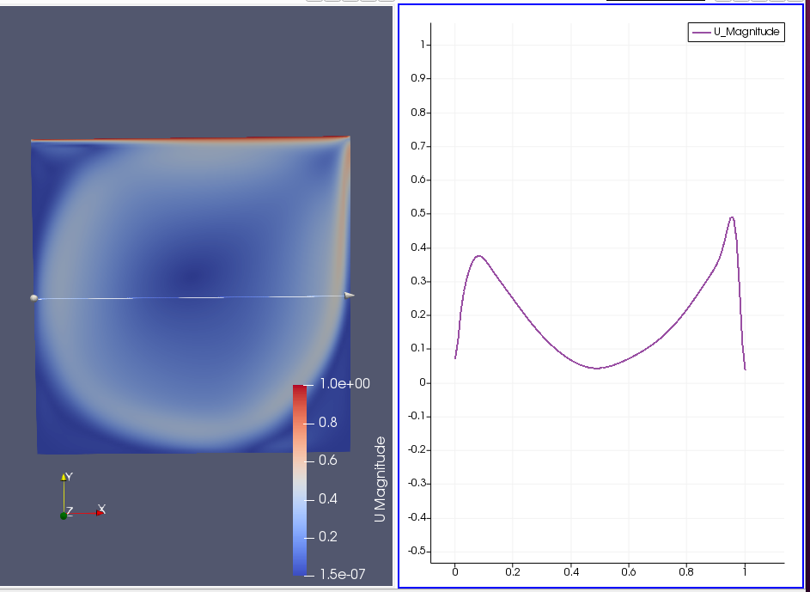

Figure Case D for using Open FOAM in the T=50 s and the velocity along the center plane

## Task 2

### Case A Stable condition



Figure Ra=200



Figure Ra=2000

As shown in figure 10,11 and 12. When the top wall temperature is high, all the cases are stable, the velocity is nearly zero, nearly 5e-14. The reason is the initial disturbances are decayed due to the viscosity.

Figure Ra=60000, dt=0.0005



### Case B

The most result of this part is as shown in question Q3.